Module 5 Critical Thinking Assignment
Programming III
CSC450-1 Fall 2025 Session C
Dr. Bindu George

Grant Brosovich
10/12/2025

Source Code:
///============================================================================
// Name : FunFileFlips.cpp
// Author : Grant Brosovich
// Version : 1
// Copyright : Some kind of Copyright
// Description : Driving class for file manipulation
//============================================================================
#include <iostream>
#include <string>
#include <fstream>

using namespace std;

class FileHandler {
//class for appending to pre-existing file
public:
void appendToFile(const string& filename) {
//ios::app performs the appending action
ofstream outfile(filename, ios::app);
if (!outfile) {
cerr << "Error opening file: " << filename << endl;
return;
}
//console displays to track process and receive input to append

string userInput;
cout << "Enter text to append to " << filename << ": ";
getline(cin, userInput);
outfile << userInput << endl;

cout << "Text successfully appended to " << filename << endl;
outfile.close();
}
};

class FileReverser {
//reversing class. takes in, closes access, calls reversing recursive function, opens/closes reverse file
public:
void reverseFile(const string& inputFile, const string& outputFile) {
ifstream infile(inputFile);
if (!infile) {
cerr << "Error opening file: " << inputFile << endl;
return;
}

string content((istreambuf_iterator<char>(infile)), istreambuf_iterator<char>());
infile.close();

string reversed = reverseRec(content);

ofstream outfile(outputFile);
if (!outfile) {
cerr << "Error opening file: " << outputFile << endl;
return;
}

outfile << reversed;
outfile.close();

cout << "Reversed content written to " << outputFile << endl;
}

private:
//reversing heavy lifter
string reverseRec(const string& str) {
if (str.empty()) {
return "";
}
//returns a shrinking original string and places the "missing" character at the end.
//Does this continually until the substring is empty.
return reverseRec(str.substr(1)) + str[0];
}
};

int main() {
const string inputFilename = "CSC450_CT5_mod5.txt";
const string reversedFilename = "CSC-mod5-reverse.txt";

FileHandler fileHandler;
FileReverser fileReverser;

fileHandler.appendToFile(inputFilename);
fileReverser.reverseFile(inputFilename, reversedFilename);

return 0;
}

Psuedocode:
Start Fun File Flips Program
-Declare file appending class
1) Open specified file in append mode
2) If file can not be opened display error and exit program
3) Prompt for user input
4) Read input from console
5) Append user input with newline
6) Display confirmation message
7) Close file
-Declare file reversing class
1) Open the input file in read mode
2) If input file cannot be opened display error message and exit program
3) Read entire content into a string
4) call function to reverse string
5) Open new output file in write mode
6) If output file cannot be opened, display error message and exit program
7) Close file
8) Display confirmation message
~Reversing function
> If string is empty then return an empty string
> Call same function with string excluding the first character
then add “missing” character to end of previous result and return the resulting string
-Declare Main function
1) Declare variables: inputFileName, reversedFilename
2) Set inputFilename to specified file
3) Set reversedFilename to specified file
4) Create FileHanlder object
5) Create FileReverser object
6) Call appending function to allow user input and appending actions
7) Call reversing function to reverse contents of appended file and write not new specified file
8) exit program
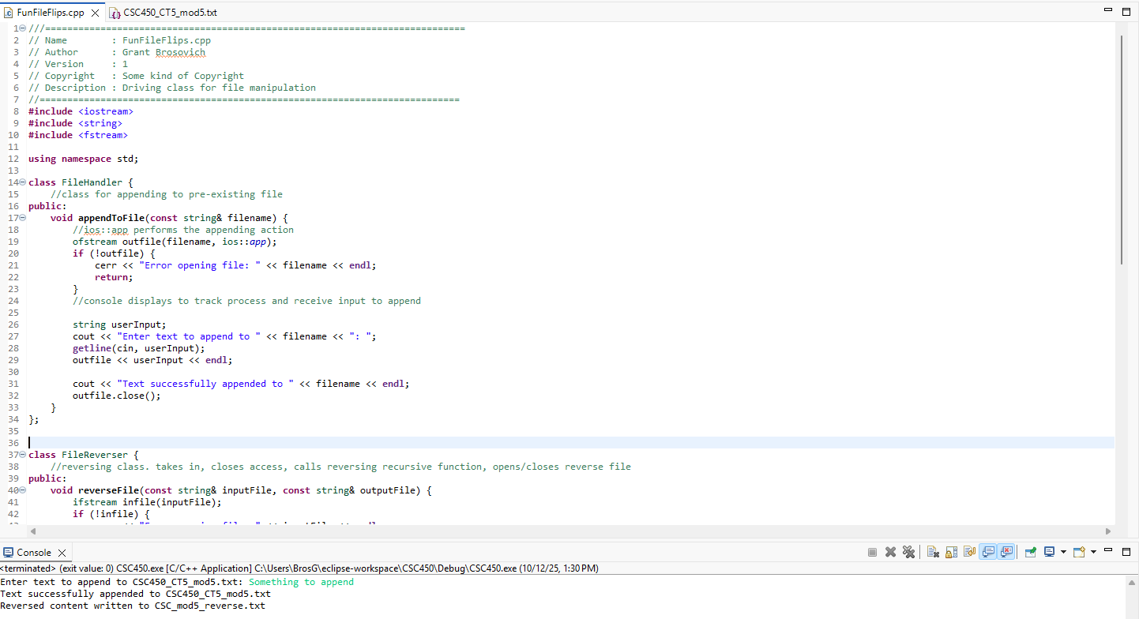
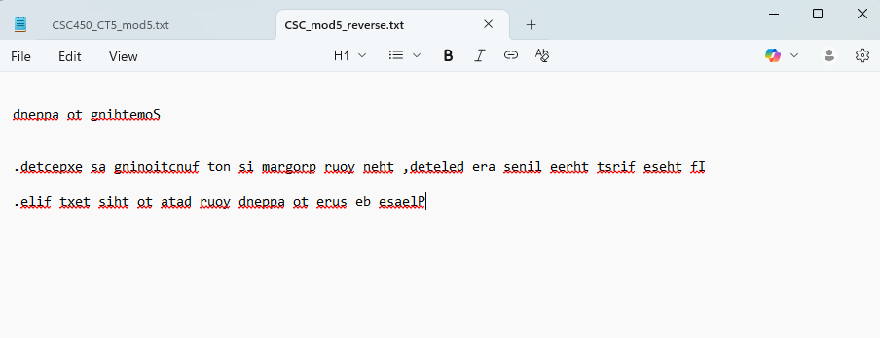
The program reads a specified text file and appends some user input to it without deleting any of the previous content. Then it reads the same file and opens a new specified file and reverses the content in character order without deleting any of the content. It opens and closes each file after performing the necessary actions.

Public GitHub Repository:


